Sand Dollar Design produces award winning app design for Mukuru

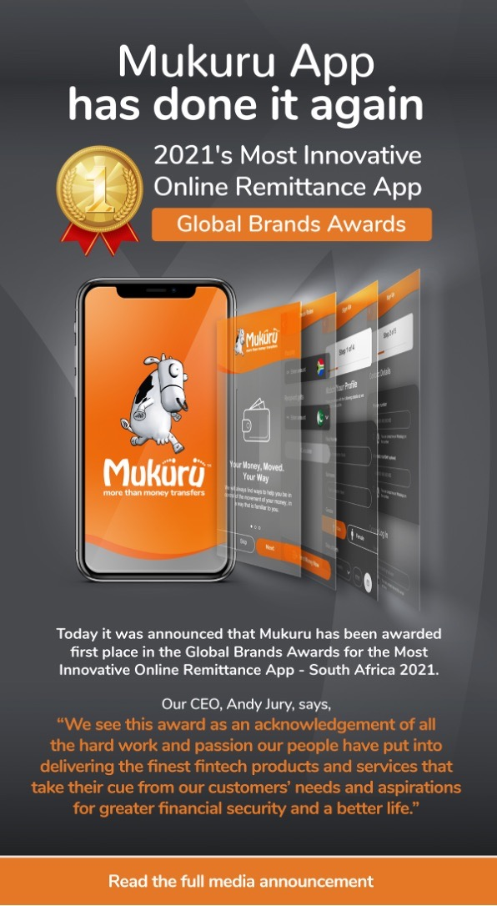

https://www.globalbrandsmagazine.com/award-winners-2021/

Mukuru Wins Most Innovative Online Remittance App in Global Brands Awards
Posted on 30th Apr 2021
GLOBAL BRANDS AWARDS announced that Mukuru has been awarded first place in the Most Innovative Online Remittance App – South Africa, 2021.

The aim of the awards is to honour companies that have performed extraordinarily well in their field, and to create global awareness around the significance of exceptional service delivery.

This year, nominations were accepted from many countries and regions, and across a range of categories. More than 7,000 companies were evaluated by an independent external research agency before a shortlist was passed to an internal team who decided the award winners based on a number of fundamental objectives.

Mukuru, Africa’s largest remittance and money transfer provider, and a leading Next Generation Financial Services Platform, this year upgraded its App to give customers even more control of their financial destinies, by enabling important transactions to be conducted from home.

The new Mukuru App (available on Android, IOS and Huawei AppGallery to download instantly) will empower customers to create orders and send money to 14 countries: Botswana, Bangladesh, DR Congo, Eswatini, Kenya, Lesotho, Malawi, Mozambique, Pakistan, Uganda, Zimbabwe, Zambia, Nigeria and Cameroon.

By creating their own user profile and personalising key features, the App will create new efficiencies for users such as enabling quick and easy repeat sends, and access to a price and rate checker. The App will also allow users to find pay in points for settling orders and/or advise their beneficiaries of collection points in their receiving countries. Importantly, existing customers can quickly and easily link their user profiles to the App and safely store and edit personal details and information.”

Mukuru CIO, Sandy Rheeder, says, “This award really validates the approach we followed when building the App – putting the customer at the centre of all transactional flows and UX design decisions, and releasing a beta product version to a subset of customers as early as we could, to get their feedback before the product was finalised.”

Partner with Sand Dollar Design to design and develop your next solution
Sand Dollar Design is an award-winning global design firm. If you or your company are considering investing in developing a mobile app, or would like our input into the decision-making process, book a free consultation with us to discuss how we can partner with you to deliver something great.

